Course Two Week Four: LOOKUP Library Activity Instructions

Open the file contained within the folder name shown above.
We want Excel to search through the book ISBN codes in this sheet:
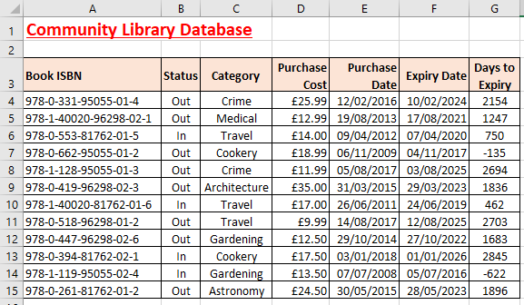
The whole spreadsheet is the lookup table
When Excel finds the ISBN code in the first column that exactly matches the ISBN code in the merged cell B18, we want Excel to complete cells B19:B22 with the correct information for that book:
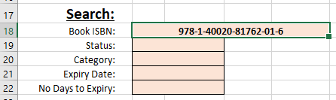
The ISBN is the code the lookup formula will find an exact match for.
First create a range name for all the data in your main spreadsheet table (A4:G15).
Also create a range name for the merged cell B18 where you will keep changing the book ISBN code.
In merged cell B19 create an exact match lookup formula to return the book status from column B (the 2nd column in your lookup table).
Remember - exact match lookup formulae have an extra variable:
=VLOOKUP(Cell to lookup, Table range, Column ref, FALSE)
Copy the formula down to merged cell B22 and then edit each formula by changing the column reference to return the correct book data.
Change the ISBN code in merged cell B18 to 978-0-662-95055-01-2 to check that all your formulae work.
Use Save As... to save the file in your own new Excel work folder.

